Wednesday, November 22, 2023

Dear Nature Nova Scotia Supporter,

A year-ender with an interesting funding opportunity!

As December creeps closer, with Giving Tuesday set for November 28th, I’d like to share some Nature Nova Scotia (NNS) news updates and inform you about an unusual offer from a funding foundation.

Fire, smoke, flash-flooding, extreme wind and drought events have serious consequences for both people and wildlife. Funding for nature groups, including the Young Naturalists Clubs, experienced a drought as well. Kids need to learn and care about the natural world, so they can become advocates for nature even after we older folk are gone.

Nature NS’ advocacy and awareness for nature has never been more needed or important. We continue to press the provincial government to do more than planning about Species at Risk. Jess Lewis, our NNS Conservation Coordinator, has been gathering current information about mainland moose and training citizens to help identify and collect the science. Meanwhile, developers are proposing gold mines and wind turbines in active mainland moose sites near Wentworth and along the Eastern Shore.

It’s become obvious that the Aquaculture Review Board has inadequate science for making decisions about a proposed oyster farm in Antigonish Harbour. NNS signed a joint statement regarding the recent loosening of protection for wetlands in the Wetland Conservation Policy.

Ecojustice is enabling East Coast Environmental Law and Nature NS to take the federal Department of Environment and Climate Change to court after they seriously disabled some of their own habitat laws.

Efforts to make the city of Halifax more wildlife/bird friendly continue, we host regular bird-watching events for new Canadians and establish new nature partnerships.

Nature NS was one of eight groups (including the David Suzuki Foundation and the Ecology Action Centre) that lodged a complaint to the federal Competition Bureau about the forest industry-based Sustainable Forestry Initiative. This certification system allows forestry industries to clear-cut public land known to have multiple Species at Risk.

In the face of 40 year forest harvest cycles, Nature NS joined a Save Our Old Forests campaign requesting that the government not harvest forests that are 80 years of age or older on public lands. Launched in Bridgetown on March 25th, this movement to save some mature forests is gaining momentum.

Nature NS, with Donna Crossland’s guidance, established a Hemlock Woolly Adelgid fund to provide temporary protection for some private land owners of significant hemlock forests.

NNS continues to partner with Nature Canada regarding joint letters to our elected provincial officials in the light of the recent nature Global Biodiversity meeting in Montreal. I’m pleased that the federal and Nova Scotia governments recently signed a Canada-Nova Scotia Nature Agreement, including $28.5 million in funding from the federal government to help the province protect an additional 82,500 hectares.

Nature Canada helped NNS hire a new student, Juli Bishwokarma to connect visible minorities with nature. Our Executive Director, Becky, gave birth to a lovely baby girl and is now on a leave of absence for a year. We thank her and wish her all the best. Jess Lewis is taking the reins in Becky’s absence.

As a nature charity with 25 member organizations, Nature NS has obtained funding for our activities from a mix of foundations and private donors.

One funder is making an exciting offer for fiscal year 2024/25: “$100,000 multiplied by the percentage of NNS’s 4,205 followers that have contributed at least $20 to NNS in its 2023-24 fiscal year.”

If NNS can inspire 4,205 members, many in our 25 groups, to each donate $20, Nature NS will receive an additional $100,000 from the Echo foundation!
Donations can be made now, during the Giving Tuesday event (Nov. 28) or until March 31, 2024, using the NNS Facebook page and website, or by sending a cheque to our address on the letterhead.

In these challenging times, if you could help us raise that sum, what a wonderful start this would be for our next NNS fiscal year!

With all good wishes,

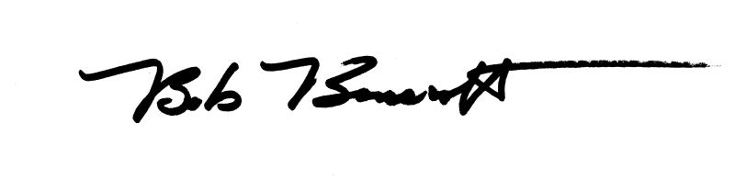
Bob Bancroft
President, Nature Nova Scotia

